Java GUI Cell Phone Bill Lab Report
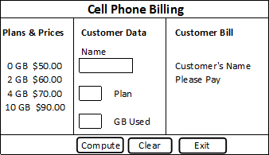
1) Enter your name, student ID, platform (Mac or PC) and date
Name and Student ID: Jibran Akhter - 1073973
Platform (Mac, PC, Linux, etc.): Windows 11 PC
Development System (NetBeans, Eclipse, etc.) Eclipse
Using JavaFX or Java Swing?: JavaFX
Date: 5/7/2024
PROJECT DESCRIPTION:
There are four plans the customer can choose from. Each plan has unlimited text and calls. The price of each plan is determined by the amount of data the customer wants to purchase each month. Data usage over the purchased limit is $15 per Gigabyte (GB) or any portion of a GB.
Plan-A: $50/month 0 GB data included
Plan-B: $60/month 2 GB data included
Plan-C: $70/month 4 GB data included
Plan-D: $90/month 10 GB data included
Create a JavaFX program using a BorderPane for a Cell Phone billing program.
1) The top position displays your name and the text, "Cell Phone Billing"
2) The left position displays a list of plans and prices
3) INPUT: The center position is used to input the customer's name, plan selection and
the number of GB used. The program is to use three JavaFX TextFields to
input the data and four JavaFX Labels for "Customer Data", "Name", "Plan",
and "GB Used". The program is to only accept either upper or lower case
letters a, b, c, or d for the plan selection and integers for the number of GB used.
4) PROCESS: The bottom pane contains three buttons, Compute, Clear and Exit
The Compute button computes the bill and displays the customer's name and bill in the right
position of the BorderPane.
The Clear button clears the TextFields for the customer name, plan selection, GB used, and the
TextArray that is used to display the bill.
5) OUTPUT: The right pane is to displays three lines:
line 1 – "Customer Bill"
line 2 – displays the name that was entered in the TextField used for the customer's name.
line 3 – displays the words, "Please pay " followed by the amount of the bill. The display of the
amount of the bill needs to include the dollar sign $ and 2 digits past the decimal.
6) A try/throw/catch construct is to be used in the program to process any input errors and display
appropriate error messages.
DISCUSSION:
2) Complete the DISCUSSION section in English. It does not need to be long.
2a) What did you do to develop the program?
To develop the JavaFX Cell Phone Billing program, I used a `BorderPane` as the main layout container to segment the application into clear, designated areas for input, output, and control. This helped organize the components logically and enhanced the user experience. Various components like `Labels`, `TextFields`, and `Buttons` were created to manage different parts of the GUI. For example, `Labels` to display instructions and results, `TextFields` for user inputs, and `Buttons` for actions like compute and clear. I implemented error handling within the compute function using try-catch blocks to manage exceptions like invalid number formats and incorrect plan entries. This ensures the program runs smoothly and provides user feedback for correction.
2b) What problems did you have and how did you overcome the problems?
One common issue was ensuring that user inputs for the plan and GB used were valid. To handle this, I used try-catch blocks to catch format and illegal argument exceptions. By providing clear error messages, users are guided to correct their inputs accordingly. Initially, there were some performance lags due to inefficient event handling. Optimizing the code by reducing redundancy and enhancing event listener functions helped in improving the responsiveness and efficiency of the application.

PROGRAM OUTPUT:
3) Provide screenshots showing

An output when plan A is selected.

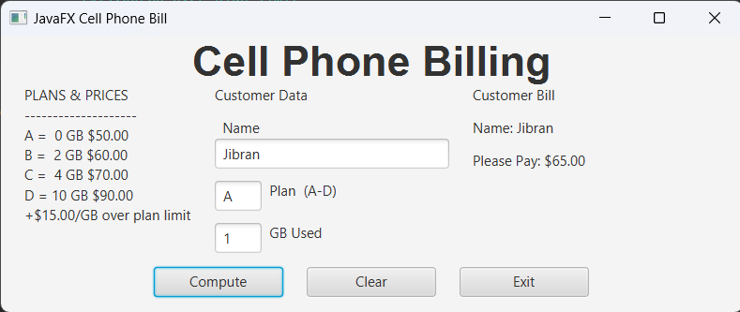

An output when plan B is selected.

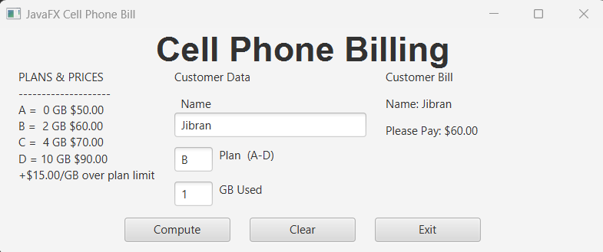

An output when plan C is selected.

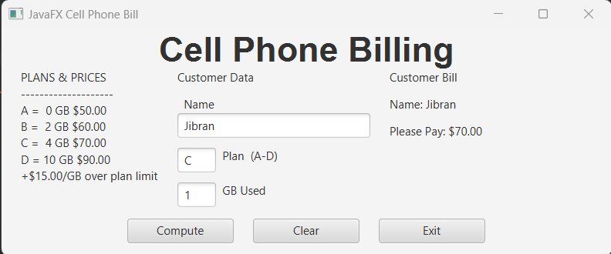

An output when plan D is selected.

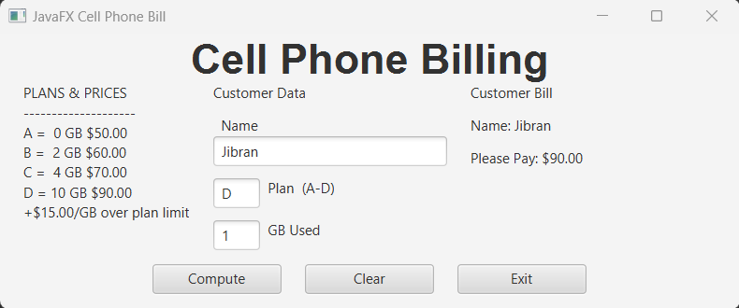

An output when an illegal plan is selected.

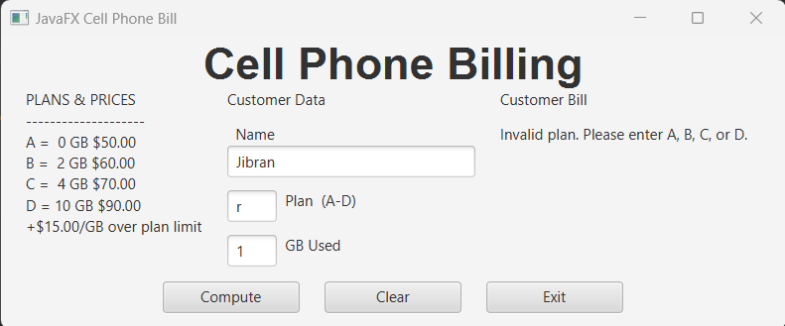

An output when anything except an integer is entered for the GB used.

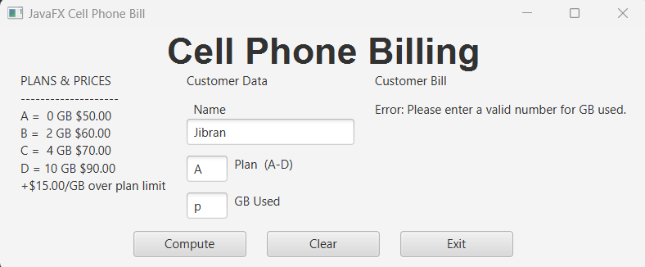

Refer to previous lab assignments to review how to save a screen shot to the lab report. Adjust the size of the image on the report to show the summary information and the image of the paycheck.
PROGRAM LISTING:
4) Copy and paste the code that YOU typed to make the program work. Your program should include a comment block at the top that shows the name of the program, date and your name.

/*
* Name: Jibran Akhter - 1073973
* Date: 5/7/2024
* Project: JavaGUICellPhoneBill
*/

package application;

import javafx.application.Application;
import javafx.geometry.Insets;
import javafx.geometry.Pos;
import javafx.scene.Scene;
import javafx.scene.control.Button;
import javafx.scene.control.Label;
import javafx.scene.control.TextField;
import javafx.scene.layout.BorderPane;
import javafx.scene.layout.HBox;
import javafx.scene.layout.VBox;
import javafx.scene.text.Font;
import javafx.scene.text.FontWeight;
import javafx.stage.Stage;

/**
*
* @author Dan McElroy
*/
public class JavaFXCellPhoneBill extends Application {
// controls for the top pane
Label lblTitle;
// controls for the left pane
Label lblPlansAndPrices;
// controls for the center pane
Label lblCustomerData;
Label lblName;
TextField txtName;
TextField txtPlan;
Label lblPlan;
TextField txtGBused;
Label lblGBused;
// controls for the right pane
Label lblCustomerBill;
Label lblCustomerName;
Label lblPleasePay;
// controls for the bottom pane
Button btnCompute;
Button btnClear;
Button btnExit;

final double PRICE_PER_GB = 15.00;

@Override
public void start(Stage primaryStage) {
BorderPane root = new BorderPane();
root.setTop(createTop());
root.setLeft(createLeft());
root.setCenter(createCenter());
root.setRight(createRight());
root.setBottom(createBottom());

Scene scene = new Scene(root);
primaryStage.setTitle("JavaFX Cell Phone Bill");
primaryStage.setScene(scene);
primaryStage.show();
}

public static void main(String[] args) {
launch(args);
}

private HBox createTop() {
HBox hbox = new HBox();
hbox.setAlignment(Pos.CENTER);
Font font36B = Font.font("Arial", FontWeight.BOLD, 36);
lblTitle = new Label("Cell Phone Billing");
lblTitle.setFont(font36B);
hbox.getChildren().add(lblTitle);
return hbox;
}

private VBox createLeft() {
VBox vbox = new VBox();
vbox.setPadding(new Insets(0, 20, 0, 20));
lblPlansAndPrices = new Label(
"PLANS & PRICES\n" +
"--------------------\n" +
"A = 0 GB $50.00\n" +
"B = 2 GB $60.00\n" +
"C = 4 GB $70.00\n" +
"D = 10 GB $90.00\n" +
"+$15.00/GB over plan limit"
);
vbox.getChildren().add(lblPlansAndPrices);
return vbox;
}

private VBox createCenter() {
VBox vbox = new VBox();
vbox.setSpacing(10.0);

lblCustomerData = new Label("Customer Data");

VBox vbox1 = new VBox();
lblName = new Label(" Name");
txtName = new TextField();
txtName.setPrefSize(200, 20);
vbox1.getChildren().addAll(lblName, txtName);

HBox hbox2 = new HBox();
txtPlan = new TextField();
txtPlan.setPrefSize(40, 20);
lblPlan = new Label(" Plan (A-D)");
hbox2.getChildren().addAll(txtPlan, lblPlan);

HBox hbox3 = new HBox();
txtGBused = new TextField();
txtGBused.setPrefSize(40, 20);
lblGBused = new Label(" GB Used");
hbox3.getChildren().addAll(txtGBused, lblGBused);

vbox.getChildren().addAll(lblCustomerData, vbox1, hbox2, hbox3);
return vbox;
}

private VBox createRight() {
VBox vbox = new VBox();
vbox.setPadding(new Insets(0, 20, 0, 20));
vbox.setMinWidth(250);
vbox.setSpacing(10.0);
vbox.setAlignment(Pos.TOP_LEFT);

lblCustomerBill = new Label("Customer Bill");
lblCustomerName = new Label("Name: ");
lblPleasePay = new Label("Please Pay:");
vbox.getChildren().addAll(lblCustomerBill, lblCustomerName, lblPleasePay);
return vbox;
}

private HBox createBottom() {
HBox hbox = new HBox();
hbox.setSpacing(20.0);
hbox.setPrefHeight(50);
hbox.setAlignment(Pos.CENTER);

btnCompute = new Button("Compute");
btnCompute.setPrefSize(110, 20);
btnCompute.setOnAction(e -> compute());

btnClear = new Button("Clear");
btnClear.setPrefSize(110, 20);
btnClear.setOnAction(e -> clear());

btnExit = new Button("Exit");
btnExit.setPrefSize(110, 20);
btnExit.setOnAction(e -> System.exit(0));

hbox.getChildren().addAll(btnCompute, btnClear, btnExit);
return hbox;
}

private void compute() {
try {
String plan = txtPlan.getText().toUpperCase();
int gbUsed = Integer.parseInt(txtGBused.getText());
double totalCost = 0;
int includedGB = 0;

switch (plan) {
case "A":
totalCost = 50.00;
includedGB = 0;
break;
case "B":
totalCost = 60.00;
includedGB = 2;
break;
case "C":
totalCost = 70.00;
includedGB = 4;
break;
case "D":
totalCost = 90.00;
includedGB = 10;
break;
default:
throw new IllegalArgumentException("Invalid plan. Please enter A, B, C, or D.");
}

if (gbUsed > includedGB) {
totalCost += (gbUsed - includedGB) * PRICE_PER_GB;
}

lblCustomerName.setText("Name: " + txtName.getText());
lblPleasePay.setText("Please Pay: $" + String.format("%.2f", totalCost));
} catch (NumberFormatException e) {
lblCustomerName.setText("Error: Please enter a valid number for GB used.");
lblPleasePay.setText("");
} catch (IllegalArgumentException e) {
lblCustomerName.setText(e.getMessage());
lblPleasePay.setText("");
}
}

private void clear() {
txtName.setText("");
txtPlan.setText("");
txtGBused.setText("");
lblCustomerName.setText("Name: ");
lblPleasePay.setText("Please Pay:");
}
}

